bruinx DASHBOARD USER Guide

iNTRODUCTION
BruinX Dashboards are interactive visual modules that synthesize and aggregate institutional data about UCLA students, faculty, and staff. The Dashboards, which provide university-wide demographic data that can be filtered, offer a common reference point for measuring and evaluating crucial features of the University.
For general information about the BruinX Dashboards, please refer to the frequently answered questions factsheet on the BruinX Dashboard landing page.

how to access dashboards
Public BruinX Dashboards are accessible via the following web address: <https://equity.ucla.edu/public_accountability/bruinx-dashboards>.
Alternatively, the BruinX Dashboards are accessible from the Office of Equity, Diversity, and Inclusion’s website: https://equity.ucla.edu and by clicking on the tab labeled “Public Accountability.”
On this BruinX Dashboards’ homepage, you have the option of viewing either Student, Staff, or Faculty data. There are also links for additional resources and other campus demographic information.
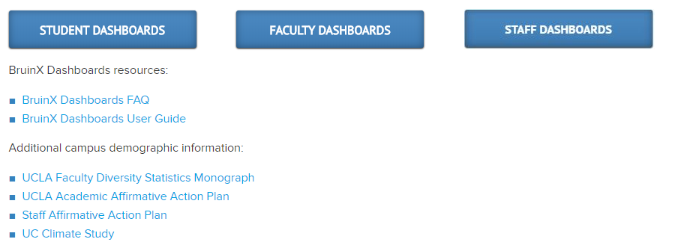

how to explore dashboards
Once you’ve chosen either Student, Staff, or Faculty, you can choose which set of data you would like to view. For example, under the “Student Dashboards” link, you can view either “Student Enrollment Headcount” or “Undergraduate Admissions.”
After making a selection, you should be directed to a page where you will see data visualizations and several built-in filters that enable you to manipulate the data in any way you’d like. We encourage users to take some time to explore – you can’t break the program!
Over the next several pages, we explain various ways to read and manipulate the Dashboards. As an example, we’ve taken screenshots of the Student Enrollment Dashboard.
This first picture shows the data visualization that you should see when you select the Student Enrollment Dashboard:
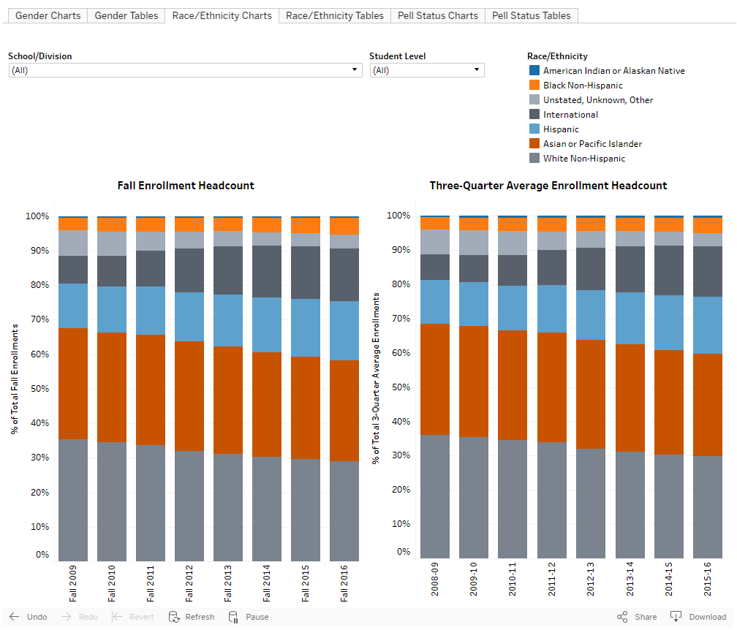

How to view the underlying aggregated data
Hover over the bar graphs to see the aggregated data used to produce the particular visualization. For example, in the chart below, the mouse is hovering over the blue section (representing Hispanic students) in Fall 2016 of the Fall Enrollments graph. We can now see that 7,761 Hispanic students, representing 17.3% of total student enrollments, were enrolled in fall 2016.
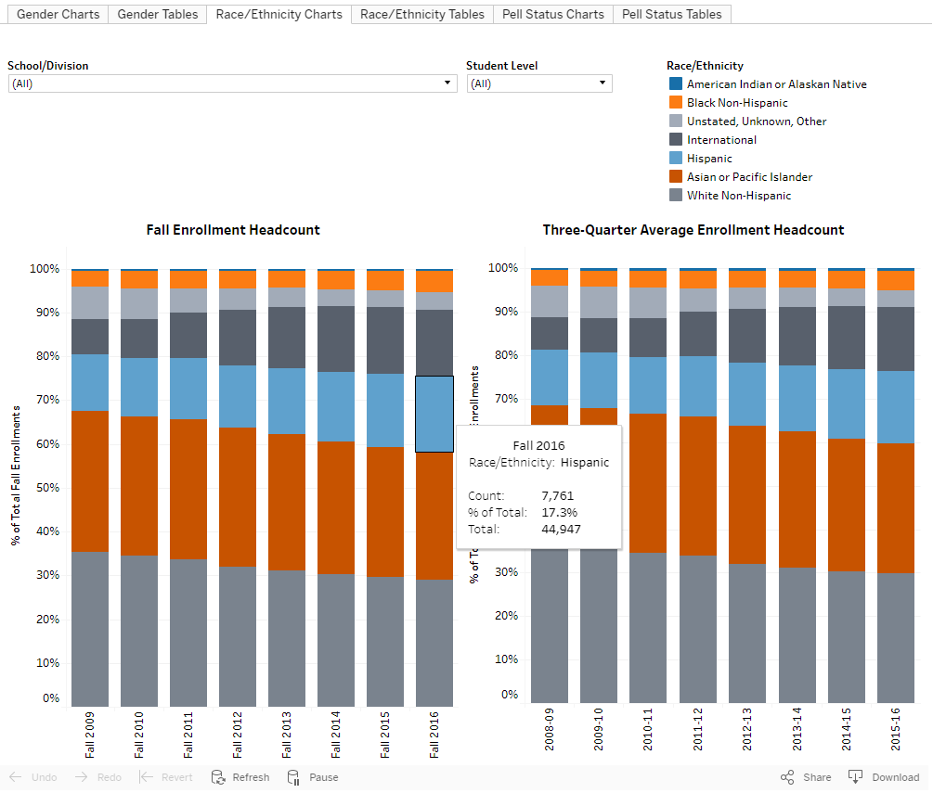

how to change the way data are displayed
You can alter the displayed data by manipulating the tabs near the top of the page. So far, the examples have displayed data in the Student Enrollment Dashboard by race/ethnicity. This means that the colors inside the bars represent various racial/ethnic groups.
To view the data differently, for instance by gender instead of race/ethnicity, click on the Gender tab. Once you do this, the colors inside the bars will change to represent Gender breakdowns by term/year of enrollment. The picture below shows the Student Enrollment Dashboard displayed in terms of gender.

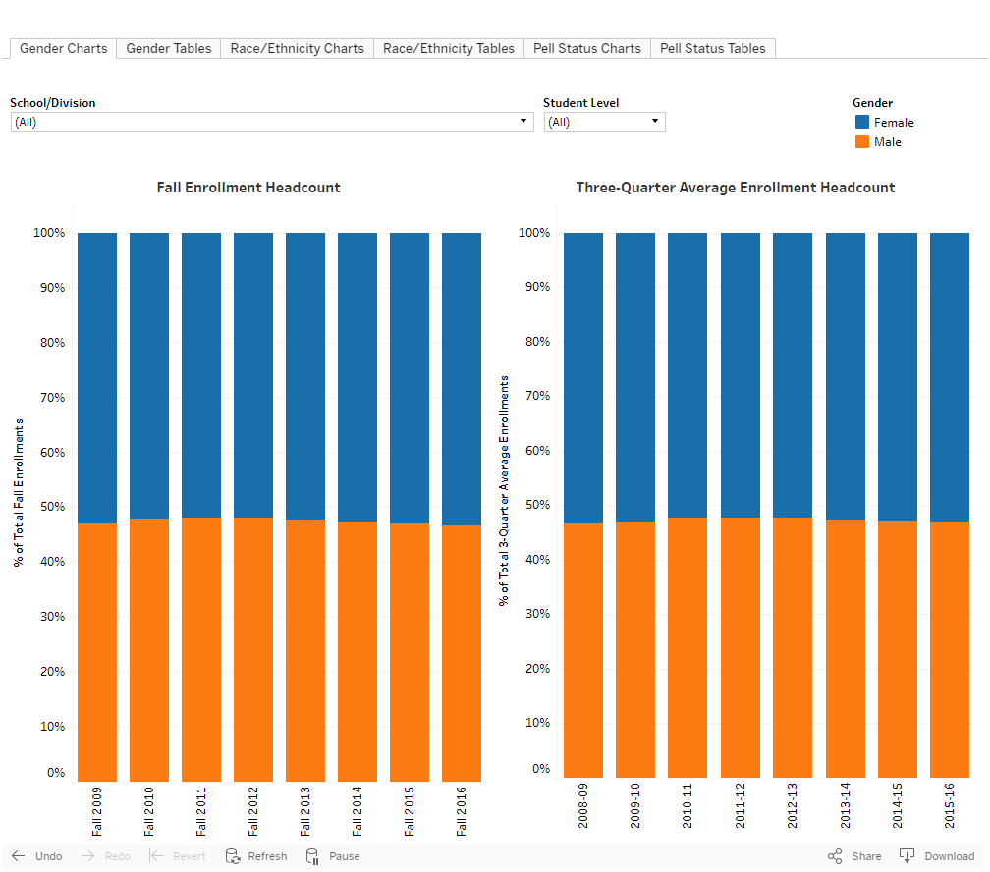

how to change what data are displayed
All Dashboards have built-in filters that enable you to further manipulate the data. As a default, no filters are selected and the data are aggregated university-wide. Using filters, you can isolate groups of interest. In the Student Enrollment Dashboard, built-in filters allow you to select school/division and student level.
To select a filter, click on the arrow next to a field name and check the box next to the value(s) you wish to see. Once you select a filter, the visualization changes to reflect those data. In the screenshot below, the Humanities Division has been selected.
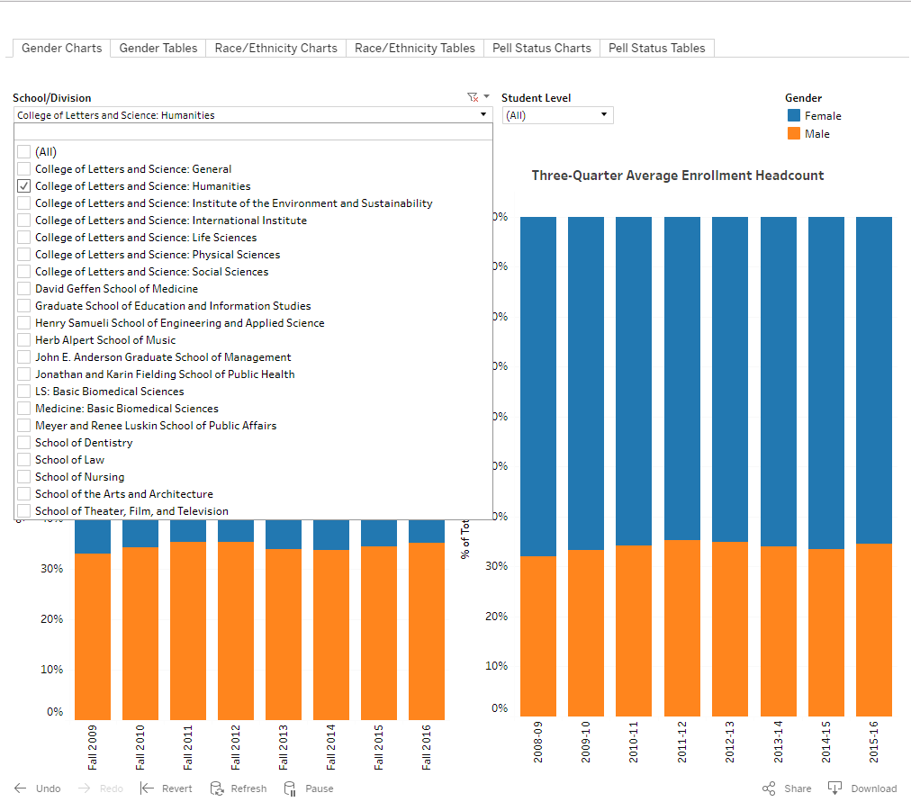

To gain an even more granular look, you can use multiple filters at once. For example, if you wish to view enrollment trends for Graduate students in the Humanities Division, you may do so using both the Student Level and School/Division filters.
You can also select multiple values within a single filter. For instance, you can view aggregated data from the Humanities and the Social Sciences divisions by selecting the box next to each Division’s name in the School/Division filter.
Currently, there is no filter for term or academic year. However, you may narrow the number of terms and/or years in the visualization by clicking on a term/year on the horizontal X-axis. Once the value is highlighted, right click your mouse and a menu will appear. In this menu, you have the options to “Keep Only” the selected term/year or “Exclude” the selected term/year.
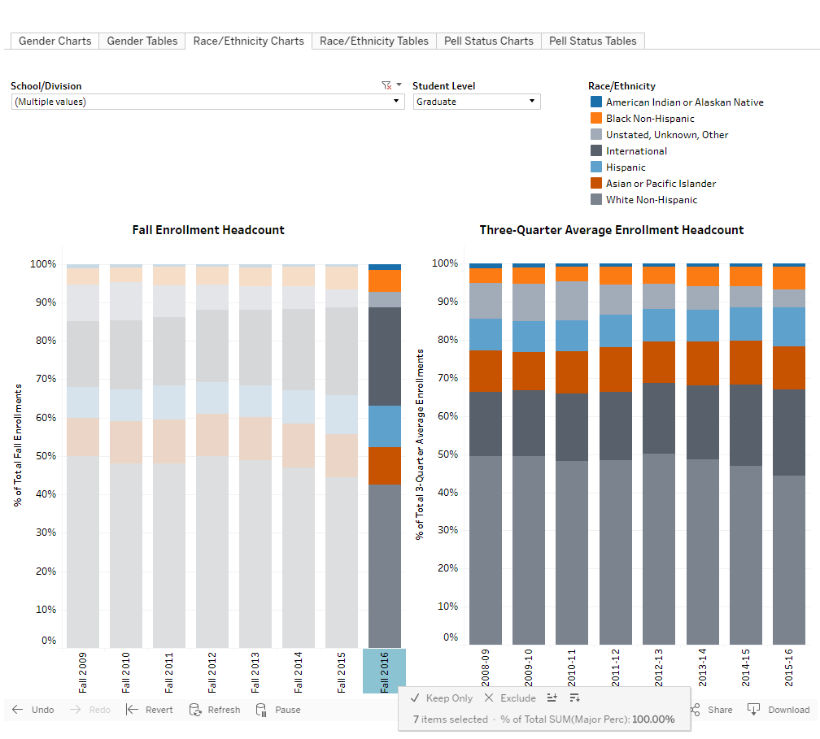

how to reset filters
To remove filters one at a time, hover over a field and click on the funnel with a red ‘X’ next to it. To reset all filters and return to default screen, scroll to the bottom of the screen and click “Revert.”
You can also use the “Undo” button at the bottom of the screen. Use this rather than the back button in your web browser.
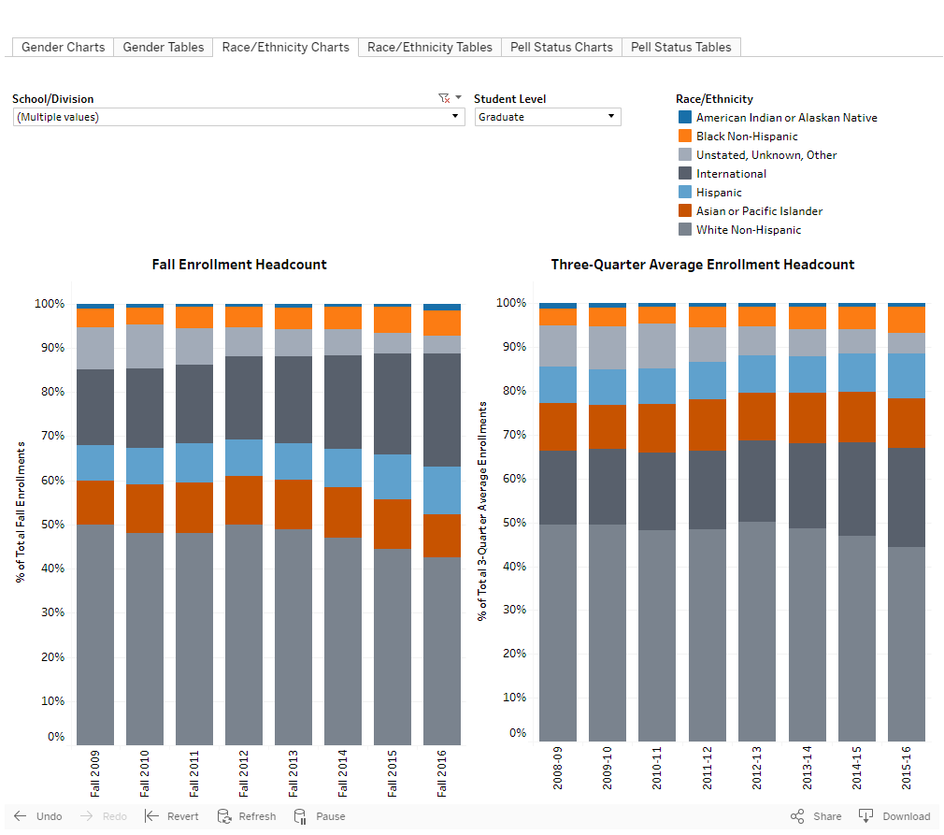

how to download visualizations and underlying summary data

download visualizations as image
To download visualizations, scroll to the bottom of the screen and click on the “Download” button. You will see options for PDF and Image. Select “PDF” if you would like to download visualizations from all tabs (e.g., Race/Ethnicity, Gender, Pell Status) into one document. Select “Image” if you would like to download visualizations from a single tab (e.g., Race/Ethnicity).
